2019 Summer Student Internship
The summer internship program run by Campaign life Coalition and The Interim Newspaper is designed to challenge and reward a select number of students with a unique opportunity to work full-time in the pro-life movement. This internship is designed to shape and form leaders by providing them with an in-depth opportunity to become active in the largest and oldest pro-life organization in Canada. Please read over the details provided below before applying.
Application Deadline: Friday 15 March 2019

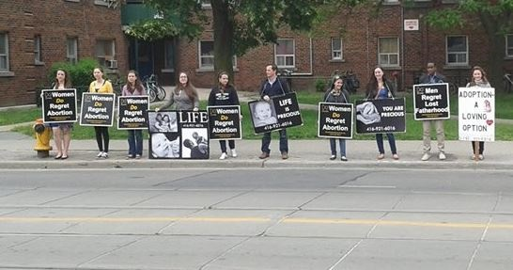
Location: Campaign Life Coalition National Office, 104 Bond St, Toronto, ON, M5B 1X9.
Hours: Monday- Friday, 9am-5pm (unless otherwise discussed), 40 hours/ week
Wage: Minimum ($14.00/ hour)
**Please note that CLC interns who are not from Toronto are responsible for finding/ paying for their own accommodations and travel arrangements. Assistance may be provided if necessary.

Internship Description:
All interns will be expected to work a full-time 40-hour work week engaging in a wide variety of tasks from administrative duties to street activism. Each intern will be expected to attend weekly training sessions to learn more about pro-life apologetics, strategizing, youth leadership, fundraising and other essential skills needed to work in the pro-life movement. Students will also be expected to participate in various activities and events CLC organizes or participates in throughout the summer months as representatives of this organization.

To apply, email the following to deny@campaignlifecoalition.com and josie@campaignlifecoalition.com
by Friday 15 March 2019.
- Completed Application Form (included below)
- Personal Reference Form (included below)
- Cover Letter
- Resume

2019 Summer Student Internship Application
Full Name:_______________________________________________________________________________________
Permanent Address: ______________________________________________________________________________
City: ____________________________ Province: ______________________ Postal Code:______________________
Present Mailing Address: ___________________________________________________________________________
City: ____________________________ Province: ______________________ Postal Code:______________________
E-mail Address: ___________________________________________________________________________________
Date of Birth: ________________________________________ Cell Phone #: ________________________________
School Information
Name of High School/ College/ University:
________________________________________________________________________________________________
City: ____________________________ Province: ______________________ Postal Code:______________________
Major (if any): ____________________________________________________________________________________
Anticipated Graduation Date: _______________________________________________________________________
Please answer the following questions:
1. What motivated you to apply for CLC’s summer internship?
________________________________________________________________________________________________________________________________________________________________________________________________________________________________________________________________________________________________________________________________________

2. Have you ever been involved in pro-life activism? (If yes, please explain).
________________________________________________________________________________________________________________________________________________________________________________________________________________________________________________________________________________________________________________________________________________________________________________________________
________________________________________________________________________________________________________________________________________________________________________________________________
3) Do you plan on being active in the pro-life movement in the future?
________________________________________________________________________________________________________________________________________________________________________________________________________________________________________________________________________________________________________________________________________________________________________________________________
________________________________________________________________________________________________________________________________________________________________________________________________
4) Please numerically rank the areas of work which match your particular skill set (1= most qualified).
Administrative Duties _________
Political Action _________
Marketing/ Fundraising _________
Activism/ Strategizing _________
Graphic Design _________
Writing/ Editing _________
Archiving _________
5) How did you hear about this summer internship opportunity?
________________________________________________________________________________________________________________________________________________________________________________________________________________________________________________________________________________________________________________________________________________________________________________________________
________________________________________________________________________________________________________________________________________________________________________________________________

Personal Reference Form
Name: _________________________________________________________________________________________
Organization (if applicable): ________________________________________________________________________
Address: ________________________________________________________________________________________
City: ____________________________ Province: ______________________ Postal Code:______________________
E-mail Address: __________________________________________________ Phone #: ________________________
What is your relationship with the applicant?
______________________________________________________________________________________________________________________________________________________________________________________________________________________________________________________
If given the opportunity, would you hire the applicant to work for you?
______________________________________________________________________________________________________________________________________________________________________________________________________________________________________________________
Please describe the applicant’s strengths:
______________________________________________________________________________________________________________________________________________________________________________________________________________________________________________________
Please describe the applicant’s weaknesses:
______________________________________________________________________________________________________________________________________________________________________________________________________________________________________________________
How has the applicant shown a commitment to the pro-life movement?
______________________________________________________________________________________________________________________________________________________________________________________________________________________________________________________
Thank-you for taking the time to complete this Reference Form. Feel free to add any additional comments which you feel would help in our selection process. Your assistance is greatly appreciated.

